2023

**HASHTAG GENERATION**

**A PROJECT REPORT**

**Submitted by**

**TEAM ID** **:** NM2023TMID02785

**TEAM LEADER** **:** HARIPRASAD N

**TEAM MEMBER :** KAPIL A

**TEAM MEMBER** **:** MADHAVAN P

**TEAM MEMBER** **:** BADRI CHELVA M

Submitted to

**Smartinternz**

**RAMCO INSTITUTE OF TECHNOLOGY**

**RAJAPALAYAM – 626 117**

**CONTENTS**

1. **INTRODUCTION** 1.1 Project Overview

1.2 Purpose

1. **IDEATION & PROPOSED SOLUTION** 2.1 Problem Statement Definition

2.2 Empathy Map Canvas

2.3 Ideation & Brainstorming

2.4 Proposed Solution

1. **REQUIREMENT ANALYSIS**

3.1 Functional requirement

3.2 Non-Functional requirements

**4. PROJECT DESIGN**

4.1 Data Flow Diagrams

4.2 Solution & Technical Architecture

4.3 User Stories

1. **RESULTS**
2. **ADVANTAGES & DISADVANTAGES**
3. **CONCLUSION**

**INTRODUCTION**

**1.1Project Overview:**

The Hashtag Generation project focuses on automating the creation of relevant hashtags for social media content. Leveraging Natural Language Processing (NLP) and machine learning models, the system analyzes content to generate contextually appropriate hashtags. The user-friendly interface enables content creators to input captions, receiving a customized list of hashtags tailored for enhanced post visibility. The technology stack includes Python, NLTK, TensorFlow/PyTorch, and social media API integrations. The project addresses hashtag selection challenges, considering platform-specific trends and character limits. Future enhancements may include multilingual support, image recognition, and social media analytics. Deployment involves cloud hosting for scalability, with security measures implemented to safeguard user data. This project report provides insights into the development process, testing, and potential future improvements, presenting a comprehensive overview of the automated hashtag generation system.

**1.2Purpose:**   
The purpose of implementing a Hashtag Generation system is to significantly enhance the efficiency and effectiveness of social media content dissemination. Hashtags serve as pivotal metadata, acting as search and categorization tools, thereby boosting content discoverability. By automating the hashtag generation process, this project aims to alleviate the time-consuming and subjective nature of manual hashtag selection. The utilization of advanced Natural Language Processing (NLP) algorithms ensures that the generated hashtags are contextually relevant, aligning with the content's tone and subject matter. This not only increases the likelihood of reaching the intended audience but also contributes to improved engagement and visibility on platforms such as Instagram, Twitter, and TikTok. The user-friendly interface empowers content creators and marketers to seamlessly integrate relevant hashtags into their posts, augmenting the impact of their social media strategies and fostering a more streamlined and effective approach to content sharing.

1. **IDEATION & PROPOSED SOLUTION**
2. **1 Problem Statement Definition**

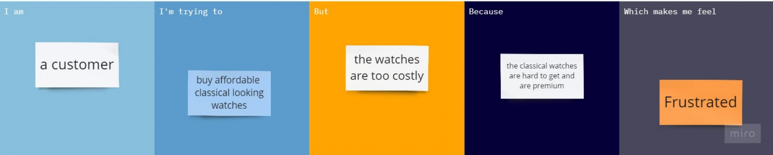

**2.2 Empathy Map Canvas**

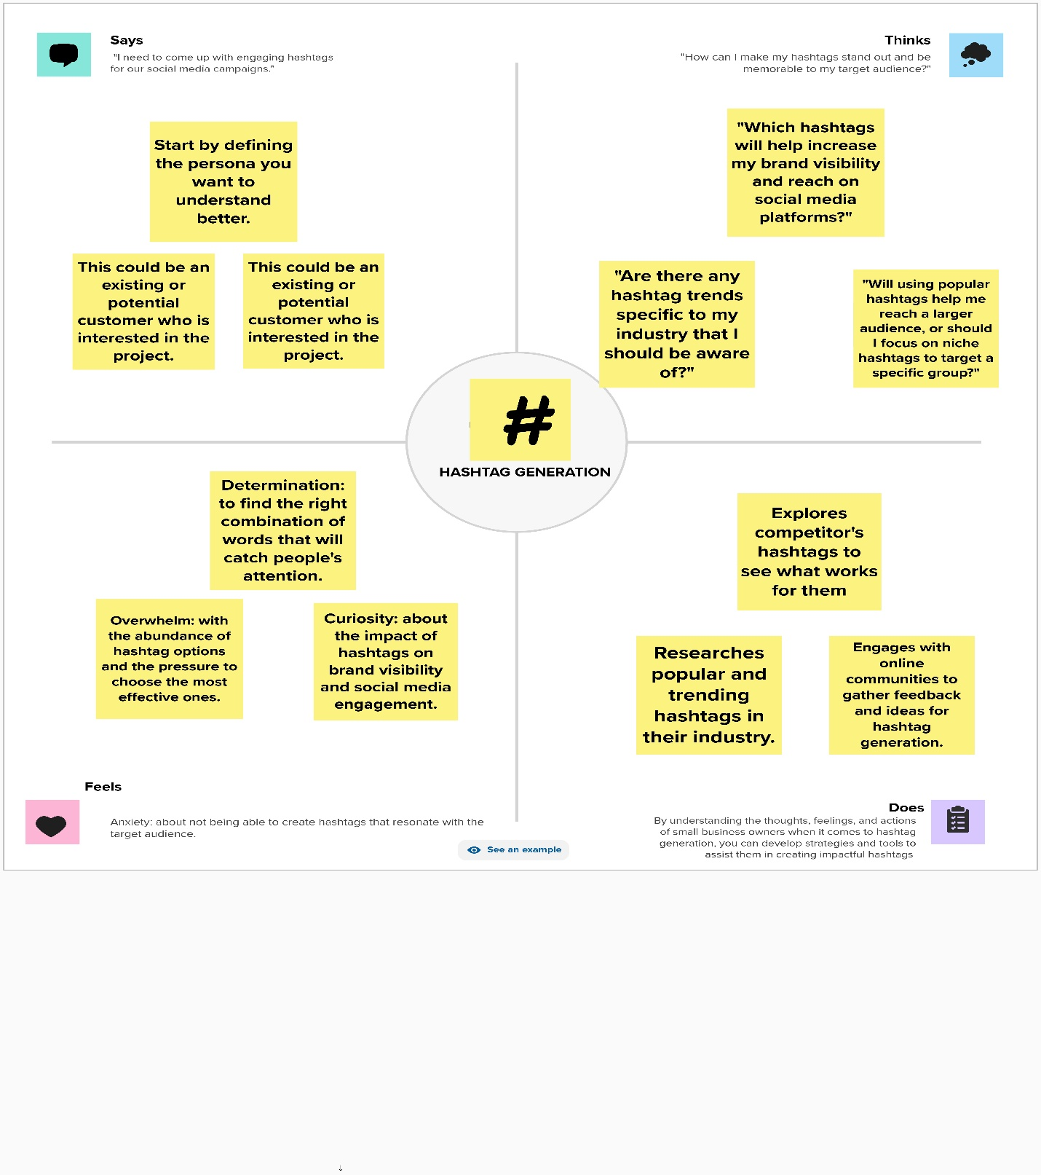

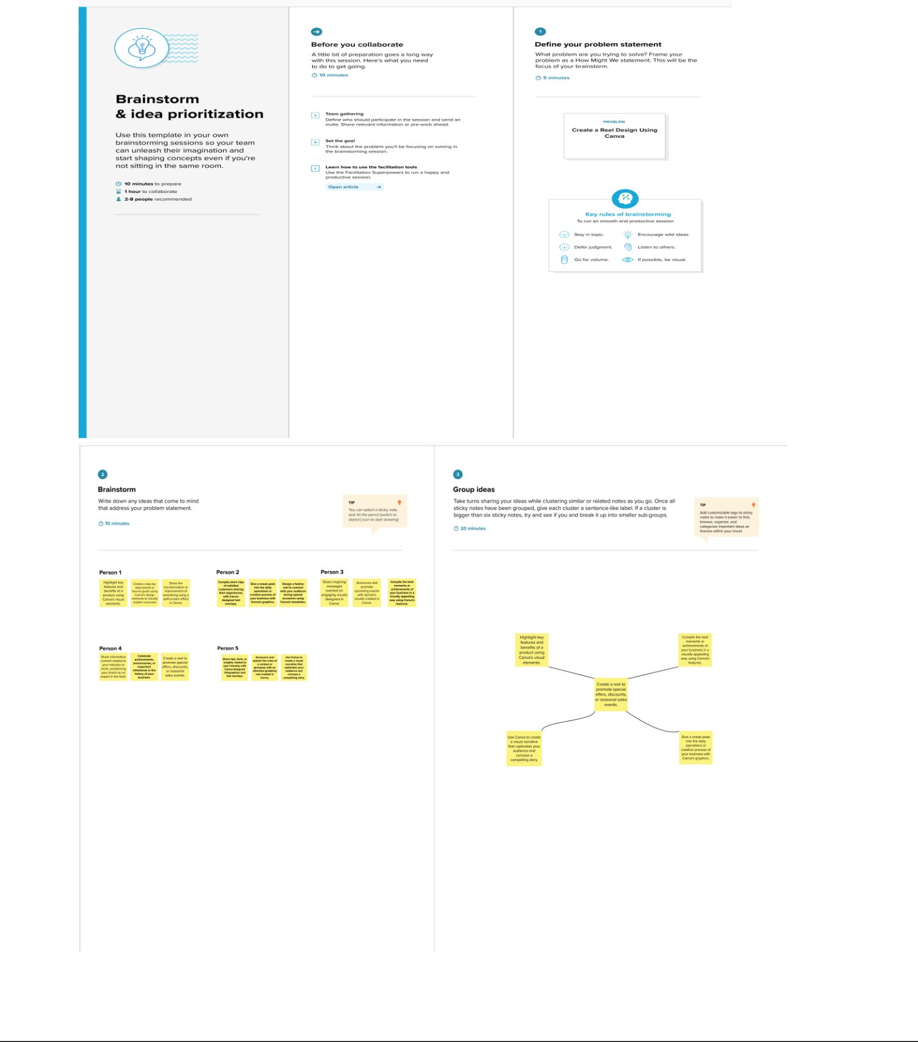

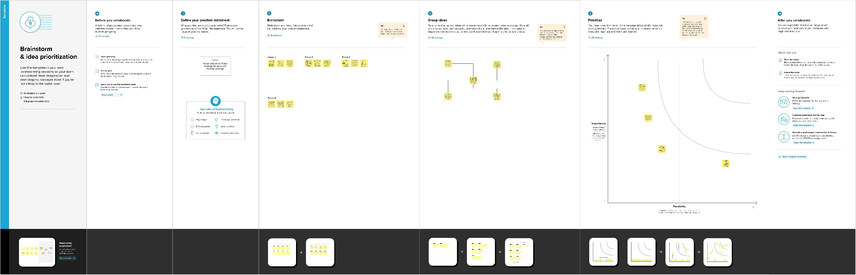**2.3 Ideation & Brainstorming**

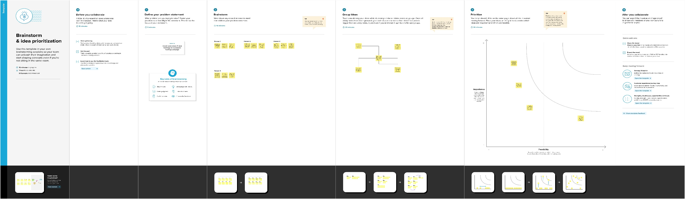

**Proposed Solution :**

|  |  |  |
| --- | --- | --- |
| **S.No.** | **Parameter** | **Description** |
|  |  |  |
| 1. | Problem Statement (Problem to be solved) | Many social media managers and small business owners |
|  |  | struggle to generate effective hashtags that resonate with their |
|  |  | target audience, increase brand visibility, and drive engagement |
|  |  | on social media platforms. They face challenges such as finding |
|  |  | unique and memorable hashtags, staying up-to-date with |
|  |  | trending and industry-specific hashtags, and determining the |
|  |  | right balance between popular and niche hashtags. Without a |
|  |  | clear strategy and effective hashtag generation tools, they may |
|  |  | experience decreased reach and difficulty in standing out |
|  |  | among competitors. |
| 2. | Idea / Solution description | Develop an artificial intelligence-based hashtag generation |
|  |  | tool that assists social media managers and small business |
|  |  | owners in creating effective hashtags. The tool should |
|  |  | provide real-time data on trending and industry-specific |
|  |  | hashtags, as well as insights into the best hashtag usage |
|  |  | strategies. Users can choose from pre-generated hashtags |
|  |  | or create their own custom hashtags by entering a few |
|  |  | keywords, phrases or sentences related to their brand or |
|  |  | campaign. The tool will use natural language processing |
|  |  | (NLP) algorithms and machine learning (ML) models to |
|  |  | generate hashtags that are relevant, unique, and likely to |
|  |  | attract their target audience. |
|  |  | . |
| 3. | Novelty / Uniqueness | Advanced AI algorithms: Utilizing advanced artificial |
|  |  | intelligence algorithms, such as natural language processing |
|  |  | (NLP) and machine learning (ML), can enhance the |
|  |  | accuracy and relevance of generated hashtags. These |
|  |  | algorithms can analyze vast amounts of data, including |
|  |  | social media trends and user behavior, to generate hashtags |
|  |  | that are more likely to resonate with the target audience. |
|  |  | Contextual understanding: A novel approach to hashtag |
|  |  | generation involves understanding the context behind a |
|  |  | social media post or campaign. By analyzing the content, |
|  |  | tone, and objectives of the post, the solution can suggest |
|  |  | hashtags that are highly relevant to the specific context, |
|  |  | ensuring better engagement and alignment with the overall |
|  |  | message. |
| 4. | Social Impact / Customer Satisfaction | In summary, hashtag generation offers a platform for |
|  |  | individuals and organizations to influence social |
|  |  | conversations, drive positive change, empower marginalized |
|  |  | voices, and build inclusive communities. By harnessing the |
|  |  | power of hashtags, people can collectively address societal |
|  |  | issues, advocate for justice, and promote a more equitable |
|  |  | and compassionate worldmore. Amplifying social causes: |
|  |  | Hashtags are commonly used to raise awareness about social |
|  |  | issues and support various causes. By generating and |
|  |  | promoting hashtags related to important social causes, |
|  |  | individuals and organizations can mobilize larger audiences, |
|  |  | engage in meaningful conversations, and drive positive chng |
|  |  |  |

|  |  |  |  |
| --- | --- | --- | --- |
| 5. | Business Model (Revenue Model) | Monetization Strategies: | |
|  |  | Consider the following monetization strategies: | |
|  |  | Freemium Model: Offer a basic version of your hashtag | |
|  |  | generation tool for free and charge a subscription fee for | |
|  |  | premium features like trend tracking, in-depth analytics, or | |
|  |  | unlimited hashtag suggestions. | |
|  |  | Pay-Per-Use: Charge users a fee for each hashtag generation | |
|  |  | request or offer prepaid packages for a set number of hashtag | |
|  |  | searches. | |
|  |  | Advertising: Incorporate relevant ads or sponsored content | |
|  |  | within the platform to generate revenue. | |
|  |  | Affiliate Marketing: Promote affiliate products or services | |
|  |  | related to social media marketing, and earn a commission for | |
|  |  | each sale made through your platform. | |
|  |  |  |  |
| 6. | Scalability of the Solution | Scaling and Innovation: |  |
|  |  | Explore opportunities to expand your services, such as |  |
|  |  | offering API integrations with other social media |  |
|  |  | management tools or developing a mobile app. |  |
|  |  | Remember that the success of your business model will |  |
|  |  | depend on the value you provide to your users and the |  |
|  |  | quality of your hashtag generation tool. Keep adapting and |  |
|  |  | refining your offering based on user feedback and market |  |
|  |  | trends to stay competitive in this space. |  |
|  |  |  |  |

3. **REQUIREMENT ANALYSIS**

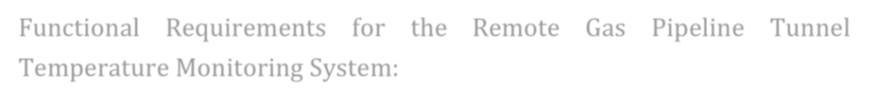

Functional Requirements for the Remote Gas Pipeline Tunnel Temperature Monitoring System:

|  |  |  |
| --- | --- | --- |
| **FR** | **Functional Requirement** | **Sub Requirement (Story / Sub-Task)** |
| **No.** | **(Epic)** |  |
| FR-1 | User Registration | Registration through Gmail |
|  |  |  |
| FR-2 | User Confirmation | Confirmation via Email or phone number |
|  |  | Confirmation via OTP |
| FR-3 | User Login | Implement a "Remember Me" option |
|  |  | Provide a "Forgot Password" feature |
| FR-4 | Profile Management | Set profile with address. |
|  |  |  |
| FR-5 | Payment Gateways | Plan with ad-free payment gateway for users to |
|  |  | order. |
| FR-6 | Reporting and Moderation | Report inappropriate content or users. |
|  |  |  |



|  |  |  |  |  |  |
| --- | --- | --- | --- | --- | --- |
| **FR** | **Non-Functional** | **Description** |  |  |  |
| **No.** | **Requirement** |  |  |  |  |
|  |  |  | | | |
| NFR- | **Usability** | Users should be able to register and | | | |
| 1 |  | create accounts easily with a valid email | | | |
|  |  | address or through social media | | | |
|  |  | integration. | Password | reset and | |
|  |  | recovery options should be available. | | | |
|  |  |  | | | |
| NFR- | **Security** | All data transmitted between the app | | | |
| 2 |  | and the server should be encrypted | | | |
|  |  | using secure protocols such as HTTPS | | | |
|  |  | to prevent interception. | |  |  |
|  |  |  |  |  |  |
| NFR- | **Reliability** | Implement | redundancy | and | failover |
| 3 |  | mechanisms | to minimize downtime. | | |
|  |  | This ensures that the app remains | | | |
|  |  | accessible even in the event of server | | | |
|  |  | failures or other issues. | |  |  |
|  |  |  | | | |
| NFR- | **Performance** | The user interface (UI) should be | | | |
| 4 |  | responsive and provide quick feedback | | | |
|  |  | to user interactions, such as food taste, | | | |
|  |  | delivery time. | |  |  |
|  |  |  |  |  |  |
| NFR- | **Availability** | Implement | redundancy | at | various |
| 5 |  | levels of the app, including servers, | | | |
|  |  | databases, and network components, to | | | |
|  |  | minimize single points of failure and | | | |
|  |  | ensure continued service availability. | | | |
|  |  |  | | | |
| NFR- | **Scalability** | Design the app to scale horizontally and | | | |
| 6 |  | vertically to accommodate a growing | | | |
|  |  | user base and increasing data load. | | | |
|  |  |  |  |  |  |

**4. PROJECT DESIGN**

**4.1 Data Flow Diagrams**

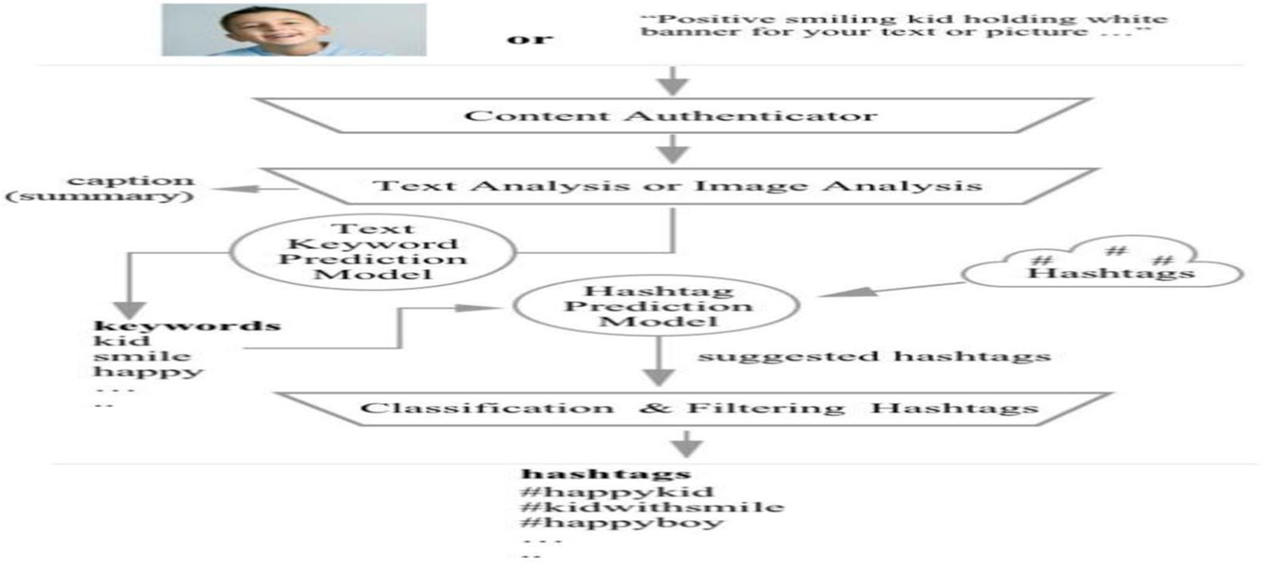

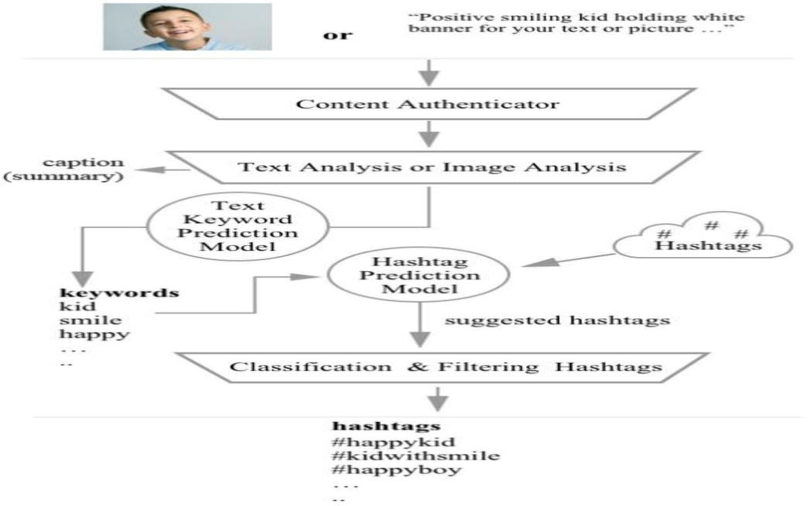

**4.2 Solution & Technical Architecture**

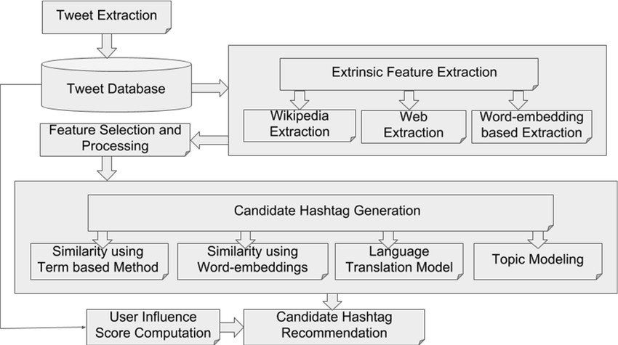

|  |  |  |  |  |  |  |  |  |  |
| --- | --- | --- | --- | --- | --- | --- | --- | --- | --- |
| **S. No** | **Component** | **Description** | | |  | **Technology** | | |  |
|  |  |  |  |  |  |  | |  |  |
| 1. | User Interface | How | user | interacts | with | Mobile | | App, | Web |
|  |  | application e.g. | | |  | application | | |  |
|  |  | Web | UI, | Mobile | App, |  |  |  |  |
|  |  | Chatbot etc. | | |  |  |  |  |  |
|  |  |  | | | |  | | |  |
| 2. | Application Logic-1 | Logic for a process in the | | | | Java / Python | | |  |
|  |  | application | |  |  |  |  |  |  |
|  |  |  | | | |  |  | |  |
| 3. | Application Logic-2 | Logic for a process in the | | | | IBM | Watson | | STT |
|  |  | application | |  |  | service | |  |  |
|  |  |  | | | |  |  |  | |
| 4. | Application Logic-3 | Logic for a process in the | | | | IBM |  | Watson | |
|  |  | application | |  |  | Assistant | | |  |
|  |  |  |  |  | |  | |  | |
| 5. | Database | Data |  | Type, | | MySQL, | | NoSQL, | |
|  |  | Configurations etc. | | |  | InfluxDB, | | |  |
|  |  |  |  |  |  | Timescale DB. | | |  |
|  |  |  | |  |  |  |  | |  |
| 6. | Cloud Database | Database | | Service | on | IBM | Cloudant | | and |
|  |  | Cloud |  |  |  | IBM Db2 | |  |  |
|  |  |  | | | |  | | | |
| 7. | File Storage | File storage requirements | | | | IBM Block Storage | | | |
|  |  |  | | | |  |  | | |
| 8. | External API-1 | Purpose of External API | | | | IBM | temperature | | |
|  |  | used in the application | | | | API, etc. | | |  |
|  |  |  | | |  |  | | |  |
| 9. | External API-2 | Purpose of External | | | API | Notification | | | API, |
|  |  | used in the application | | | | etc. |  |  |  |
|  |  |  | |  | |  | | |  |
| 10. | Machine Learning Model | Purpose | | of Machine | | Temperature | | |  |
|  |  | Learning Model | | |  | anomaly detection. | | | |
|  |  |  | |  | |  | |  | |
| 11. | Infrastructure (Server / | Application | | Deployment | | Local, | | Cloud | |
|  | Cloud) | on Local System / Cloud | | | | Foundry. | | |  |
|  |  | Local |  | Server | |  |  |  |  |
|  |  | Configuration: | | |  |  |  |  |  |
|  |  | Cloud |  | Server | |  |  |  |  |
|  |  | Configuration : | | |  |  |  |  |  |
|  |  |  |  |  |  |  |  |  |  |

**4.3 User Stories**

|  |  |  |  |  |  |  |
| --- | --- | --- | --- | --- | --- | --- |
| **User Type** | **Functional** | **User** | **User Story /** | **Acceptance** | **Priority** | **Team** |
|  | **Requirement** | **Story** | **Task** | **criteria** |  | **Member** |
|  | **(Epic)** | **Number** |  |  |  |  |
| Customer(Mobile user) | FR-001: Reel | USN- | As a | I can access the | High | Jackson |
|  | Creation Tool | 001 | marketing | marketing reel |  |  |
|  |  |  | team | creation tool. |  |  |
|  |  |  | member, I |  |  |  |
|  |  |  | want to |  |  |  |
|  |  |  | create a new |  |  |  |
|  |  |  | marketing |  |  |  |
|  |  |  | reel so I can |  |  |  |
|  |  |  | showcase |  |  |  |
|  |  |  | our products |  |  |  |
|  |  |  | and services |  |  |  |
|  |  |  | effectively. |  |  |  |
|  | FR-002: | USN- | As a user, I | I can select and | High | Jackson |
|  | Media | 002 | want to be | upload video |  |  |
|  | Upload |  | able to | clips and |  |  |
|  |  |  | upload video | images. |  |  |
|  |  |  | clips and |  |  |  |
|  |  |  | images to |  |  |  |
|  |  |  | use in the |  |  |  |
|  |  |  | marketing |  |  |  |
|  |  |  | reel. |  |  |  |
|  | FR-003: | USN- | As a user, I | I can drag and | High | Hariprasad |
|  | Content | 003 | want to | drop to arrange |  |  |
|  | Editing |  | arrange and | the sequence. |  |  |
|  |  |  | edit the order |  |  |  |
|  |  |  | of video clips |  |  |  |
|  |  |  | and images |  |  |  |
|  |  |  | in the |  |  |  |
|  |  |  | marketing |  |  |  |
|  |  |  | reel. |  |  |  |
|  | FR-004: Text | USN- | As a user, I | I can add text | High | Hariharan |
|  | Overlay | 004 | want to add | and customize |  |  |
|  |  |  | captions and | its appearance. |  |  |
|  |  |  | text overlays |  |  |  |
|  |  |  | to the |  |  |  |
|  |  |  | marketing |  |  |  |
|  |  |  | reel. |  |  |  |
|  | FR-005: | USN- | As a user, I | I can choose | High | Madhan |
|  | Background | 005 | want to | from a library of |  |  |
|  | Music |  | select | background |  |  |
|  |  |  | background | music. |  |  |
|  |  |  | music for the |  |  |  |
|  |  |  | marketing |  |  |  |
|  |  |  | reel. |  |  |  |
| Customer (Web user) |  | SU-001 | As a | I can access | High | Jayasuriya |
|  |  |  | customer, I | the marketing |  |  |
|  |  |  | want to | reel creation |  |  |
|  |  |  | create | tool from my |  |  |
|  |  |  | marketing | subscriber |  |  |
|  |  |  | reels using | account. |  |  |
|  |  |  | the online |  |  |  |
|  |  |  | tool for |  |  |  |

|  |  |  |  |  |  |  |
| --- | --- | --- | --- | --- | --- | --- |
|  |  |  | sharing |  |  |  |
|  |  |  | content and |  |  |  |
|  |  |  | promotions |  |  |  |
|  |  |  | with my |  |  |  |
|  |  |  | network. |  |  |  |
| Customer Care Executive |  | CC-001 | As a | I can access | High | Hariprasad |
|  |  |  | customer | the subscriber's |  |  |
|  |  |  | care | marketing reel |  |  |
|  |  |  | executive, I | project to assist |  |  |
|  |  |  | want to assist | with |  |  |
|  |  |  | customers in | troubleshooting. |  |  |
|  |  |  | using the |  |  |  |
|  |  |  | marketing |  |  |  |
|  |  |  | reel tool, |  |  |  |
|  |  |  | provide |  |  |  |
|  |  |  | support, and |  |  |  |
|  |  |  | troubleshoot |  |  |  |
|  |  |  | issues. |  |  |  |
| Administrator |  | ADM- | As an | I can add, | High | Hariharan |
|  |  | 001 | administrator, | modify, and |  |  |
|  |  |  | I want to | remove user |  |  |
|  |  |  | manage user | accounts and |  |  |
|  |  |  | access to the | assign roles. |  |  |
|  |  |  | marketing |  |  |  |
|  |  |  | reel tool and |  |  |  |
|  |  |  | set user roles |  |  |  |
|  |  |  | and |  |  |  |
|  |  |  | permissions. |  |  |  |

**6.RESULTS**

**HASHTAG 1:**

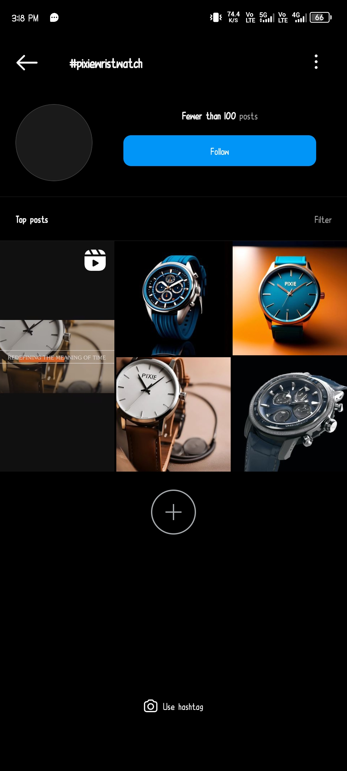

**HASHTAG 2:**

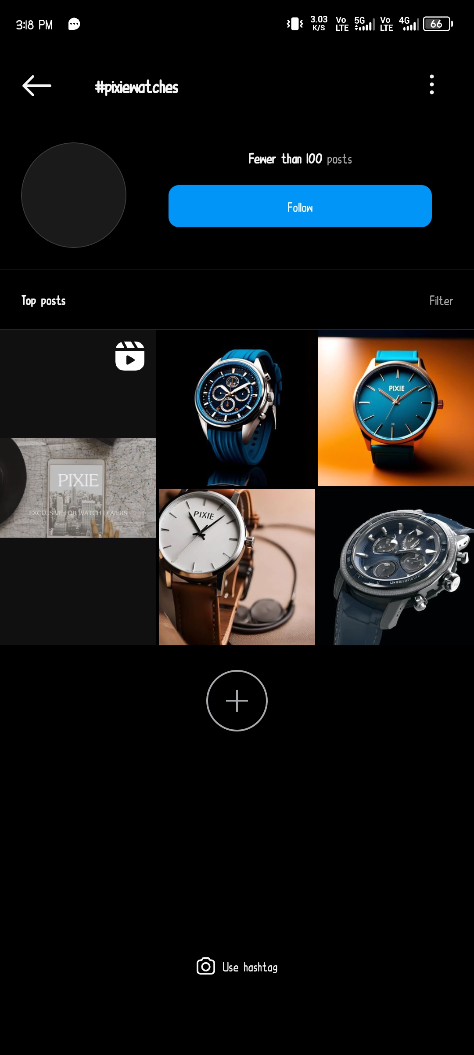

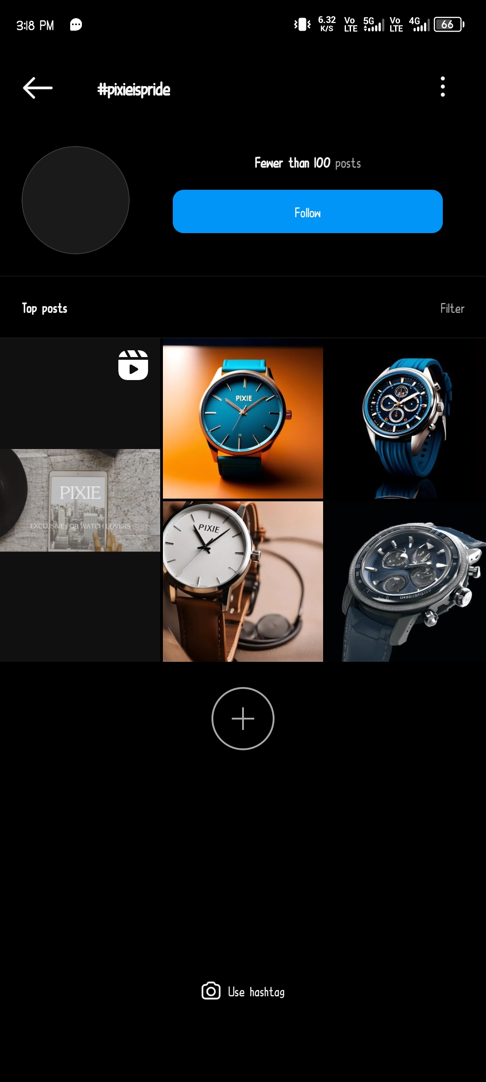**HASHTAG 3:**



**HASHTAG 4:**

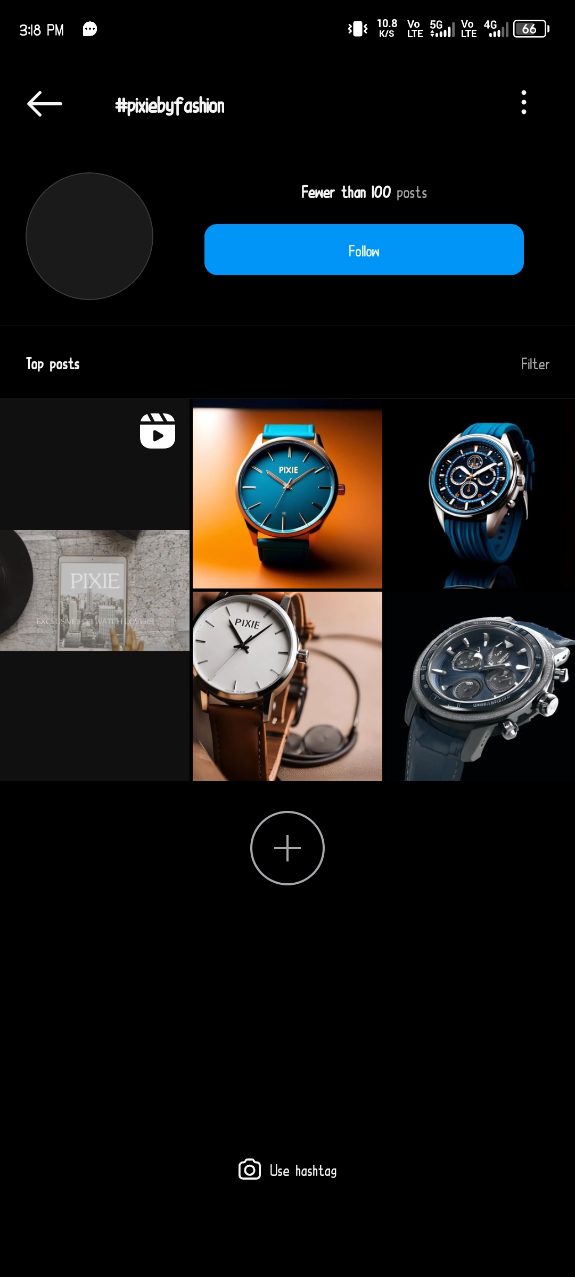



**HASHTAG 5:**

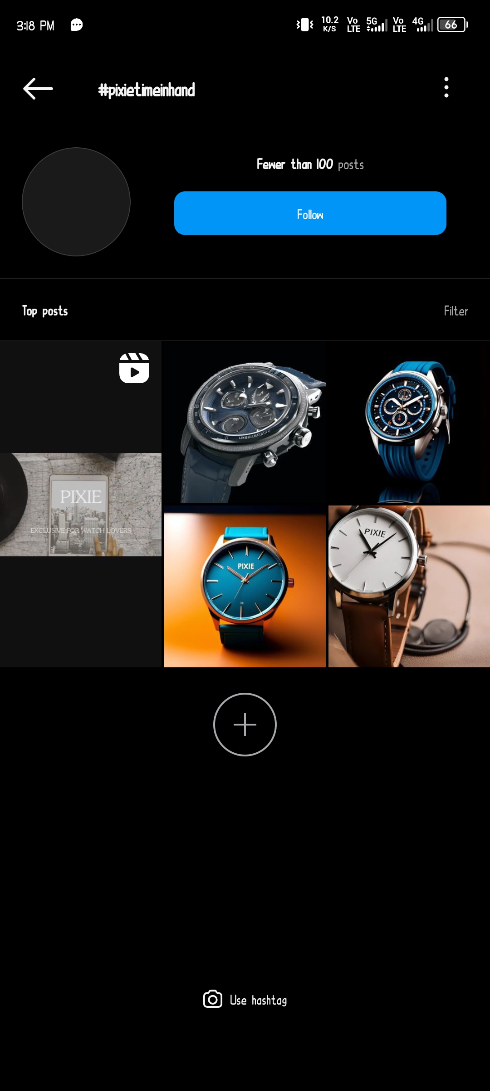

**7. ADVANTAGES ND DISADVANTAGE:**

**Advantages:**

1. **Enhanced Visibility:** Leveraging Instagram Reels for restaurant promotion significantly increases visibility due to the platform's extensive user base. Reels, with their engaging and entertaining short videos, often reach a wider audience, allowing your restaurant to be discovered by users who may not have otherwise found you.
2. **Engagement and Interaction:** Reels encourage high engagement rates through likes, comments, and shares. Users tend to interact more with video content, enabling your restaurant to build a stronger connection with the audience. Viewers can ask questions, leave comments, or share their experiences, fostering a sense of community and increasing brand loyalty.
3. **Showcasing Creativity and Personality:** Instagram Reels provide a creative space to showcase the personality of your restaurant. By creating visually appealing and entertaining short videos, you can display your unique dishes, the ambiance of your restaurant, behind-the-scenes glimpses, special events, or chef's cooking techniques, allowing potential customers to get a feel for what sets your establishment apart.
4. **Viral Potential:** Reels have the potential to go viral, especially if they are creative, relatable, or entertaining. A viral Reel can rapidly increase your restaurant's visibility, reaching a massive audience and potentially attracting a flood of new customers.
5. **Trend Utilization and Discoverability:** Reels often include trending sounds, challenges, and formats. By participating in these trends or creating your own, your restaurant can increase discoverability within the platform, as these trends often have their own dedicated sections, making it easier for users to find and engage with your content.
6. **Call-to-Action Opportunities:** Instagram Reels offer the chance to include call-to-action elements like links, prompts, or captions that direct viewers to your restaurant's page or website, encouraging them to make reservations, order online, or explore your menu further.
7. **Insights and Analytics:** Instagram provides insights into Reels' performance, including views, likes, shares, and saves. These analytics help in understanding what content resonates best with your audience, allowing you to fine-tune your promotional strategies for maximum impact.

**Disadvantages:**

1. **Saturation and Competition:** In an overcrowded platform like Instagram, the market for restaurant promotions via reels is highly competitive. With numerous eateries vying for attention, it can be challenging to stand out among the plethora of content. The oversaturation might make it difficult for your restaurant to gain visibility and reach your target audience effectively.
2. **Short Attention Spans:** Instagram reels are short-form videos, typically lasting up to 60 seconds. This limited timeframe may not adequately convey the essence of your restaurant, menu, or the overall dining experience. Capturing the attention of potential customers within this brief window can be challenging, especially when trying to showcase the uniqueness of your establishment.
3. **Algorithm Changes and Visibility:** Instagram's algorithm changes frequently, affecting the visibility of content. Despite creating engaging and high-quality reels, there's no guarantee of consistent visibility, as the algorithm may limit the reach of your content, making it harder to connect with your intended audience. This variability can impact the effectiveness of your promotional efforts.
4. **High Production and Time Investment:** Creating engaging reels demands a significant investment of time, effort, and sometimes money. The need for high-quality production, creativity, and continuous content creation can be demanding, especially for small restaurant owners or those with limited resources. Maintaining a consistent and high-quality presence on Instagram reels can become time-consuming and costly.
5. **Lack of Conversion and Return on Investment:** While Instagram reels can create buzz and interest, converting views into actual customers or revenue might not be straightforward. Generating tangible results from reel promotions, such as increased reservations or orders, might be challenging to measure directly, making it difficult to gauge the return on investment for the resources allocated to these promotional efforts.

**8.Application:**

1. **Showcasing Culinary Delights:** Use Reels to display visually appealing and mouth-watering shots of signature dishes, new menu items, or chef's specials. Highlight the artistry of food preparation and presentation to entice viewers.
2. **Behind-the-Scenes Glimpses:** Offer a sneak peek into the kitchen, introducing the team, sharing cooking techniques, or demonstrating the process of creating a popular dish. This personal touch can humanize the brand and create a connection with the audience.
3. **Sharing Customer Experience:** Feature satisfied customers enjoying their meals or having a great time at the restaurant. User-generated content or testimonials can build trust and credibility among potential diners.
4. **Promoting Events and Specials:** Announce upcoming events, promotions, or special offers through Reels. Whether it's a live music night, a themed dinner, happy hour deals, or limited-time menu items, Reels can create buzz and urgency among viewers.
5. **Engaging Challenges or Contests:** Run interactive challenges or contests, like "best food plating" or "caption this dish," encouraging user participation. User-generated content can be reshared, creating a sense of community and involvement.
6. **Educational Content:** Share cooking tips, culinary trivia, or the story behind a particular dish. This type of content can be both entertaining and informative, positioning the restaurant as an authority in the culinary domain.
7. **Incorporating Trends and Humor:** Jump on relevant trends or create light-hearted, entertaining content that aligns with the restaurant's brand. Humorous or trendy Reels often have a higher chance of going viral, expanding reach and engagement.
8. **Collaborations and Influencer Marketing:** Collaborate with local influencers, food bloggers, or other businesses for cross-promotion. Featuring them in Reels or having them create content related to the restaurant can widen the audience reach.

**9.Conclusion:**

In conclusion, leveraging Instagram Reels to promote a restaurant offers a dynamic and engaging platform to captivate audiences, showcase culinary expertise, and entice potential customers. The ability to convey a restaurant's ambiance, signature dishes, behind-the-scenes glimpses, and special events in short, visually compelling clips can significantly enhance brand visibility and attract a wider audience. The interactive nature of Reels, with its potential to go viral and reach diverse demographics, presents an unparalleled opportunity for creative storytelling and fostering connections with both local patrons and a global online community. By consistently producing high-quality, innovative content on Instagram Reels, restaurants can not only increase their visibility but also solidify their brand identity, ultimately driving foot traffic, boosting sales, and fostering a loyal customer base. The way restaurants market themselves, creating a powerful, immersive, and influential presence in the digital landscape has increased.

**INSTAGRAM LINK :**

<https://instagram.com/__.pixiewatch.__?igshid=OGQ5ZDc2ODk2ZA>==

**Github Link:** <https://github.com/HorridHari/Naan-Mudhalvan-project-Hashtag-Generation>

**Demo Link :**

<https://drive.google.com/file/d/1Ejxjp8k6GV-MGdq8iVw38D-y02naDOzX/view?usp=sharing>